

CIS C290

M02 Assignment: Complete Python Tutorial

Part 1. Visit W3 Schools Python Tutorial and complete the following 20 modules and provide one screenshot per tutorial from the W3Schools' Python Editor (Click the Try Yourself) button.

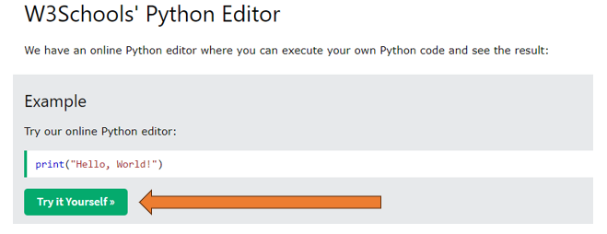

Provide 1 screenshot per tutorial. There should be 20 screenshots total. Include the name of the tutorial

EXAMPLE

Python Intro Tutorial
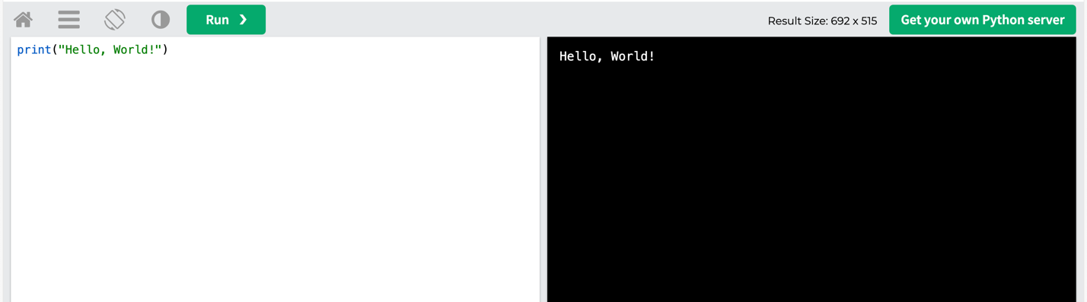

Python Tutorials
- Python Intro
Python Hello World Tutorial
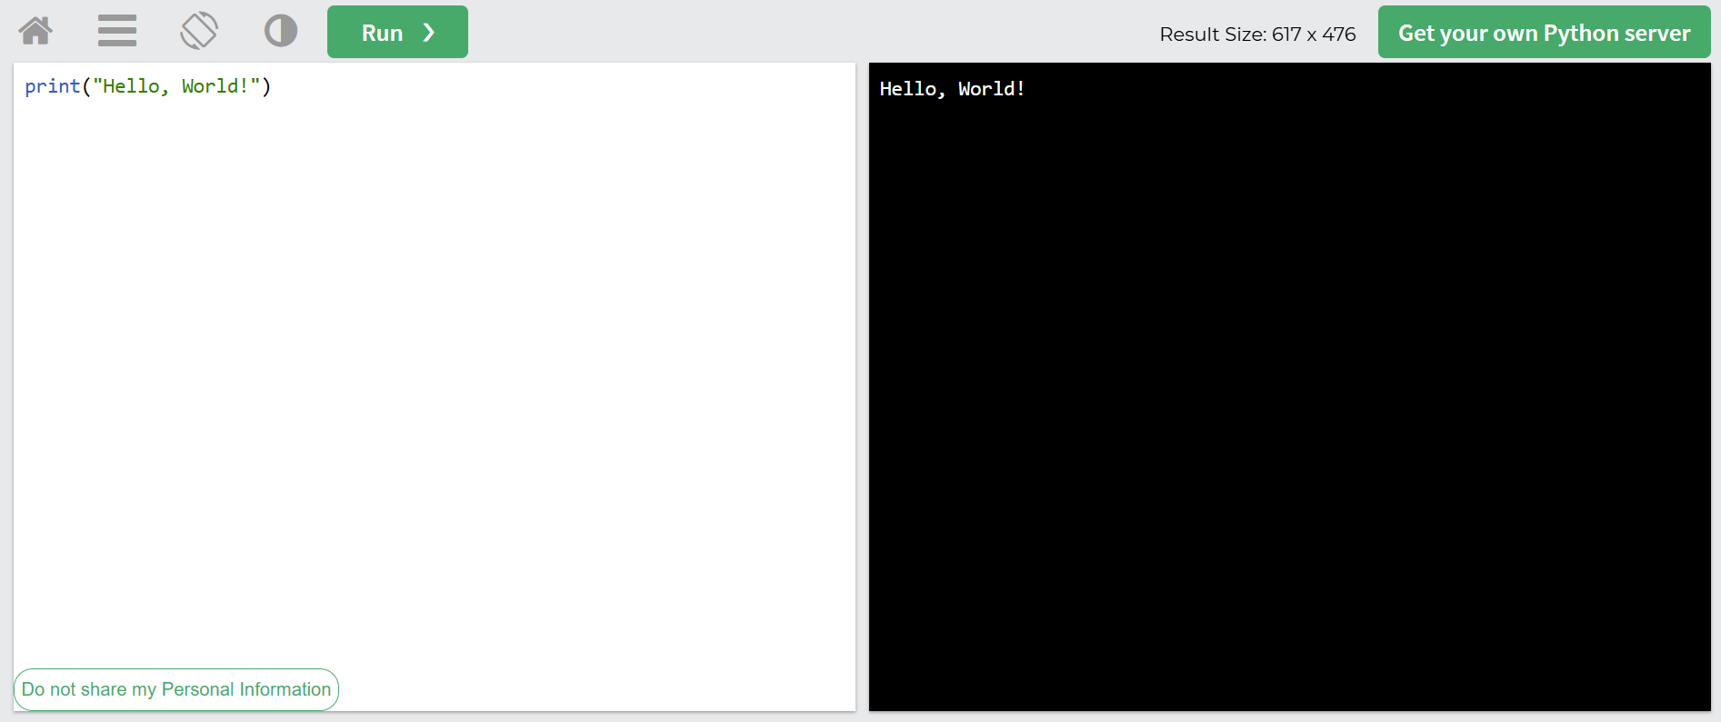

- Python Get Started
Checking Python Version
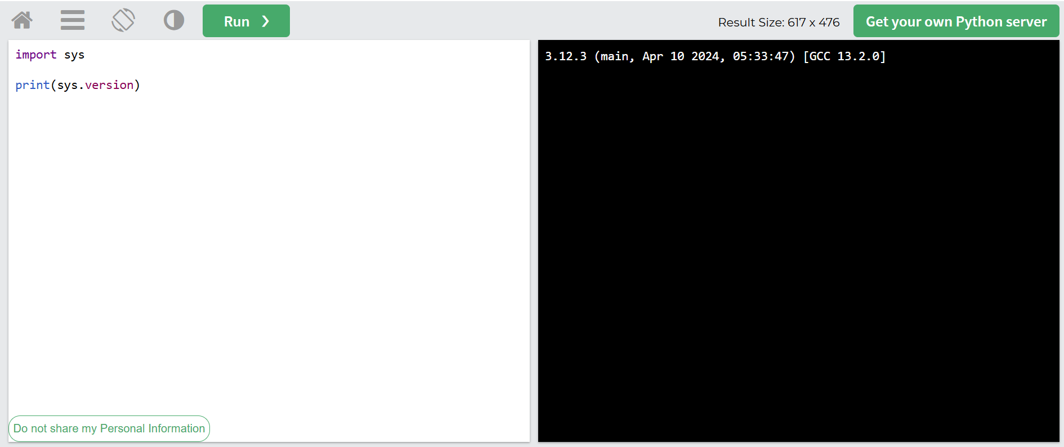
- Python Syntax
Need to have consistent indentation space
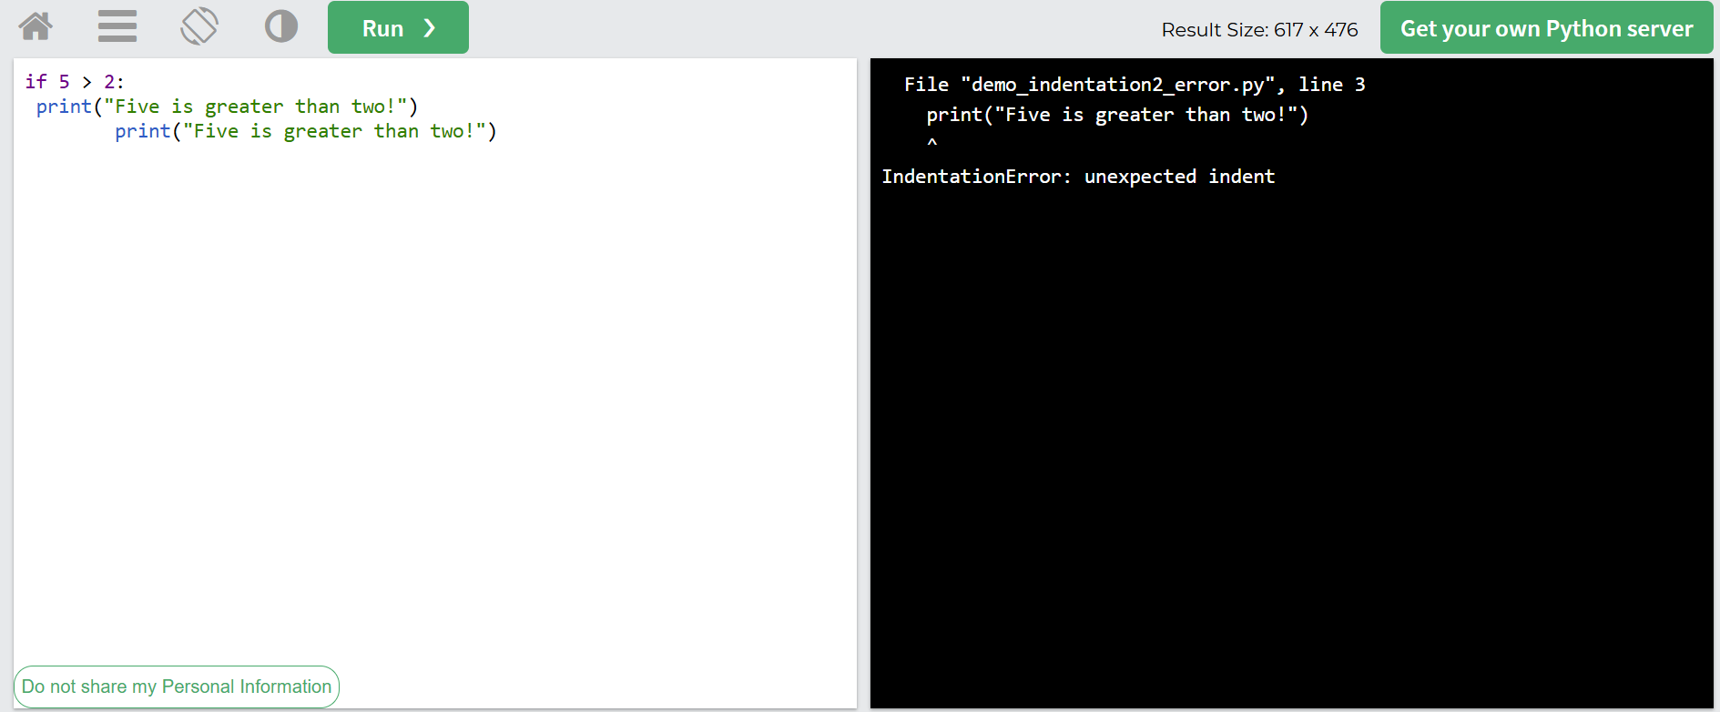
- Python Comments
Python Comment
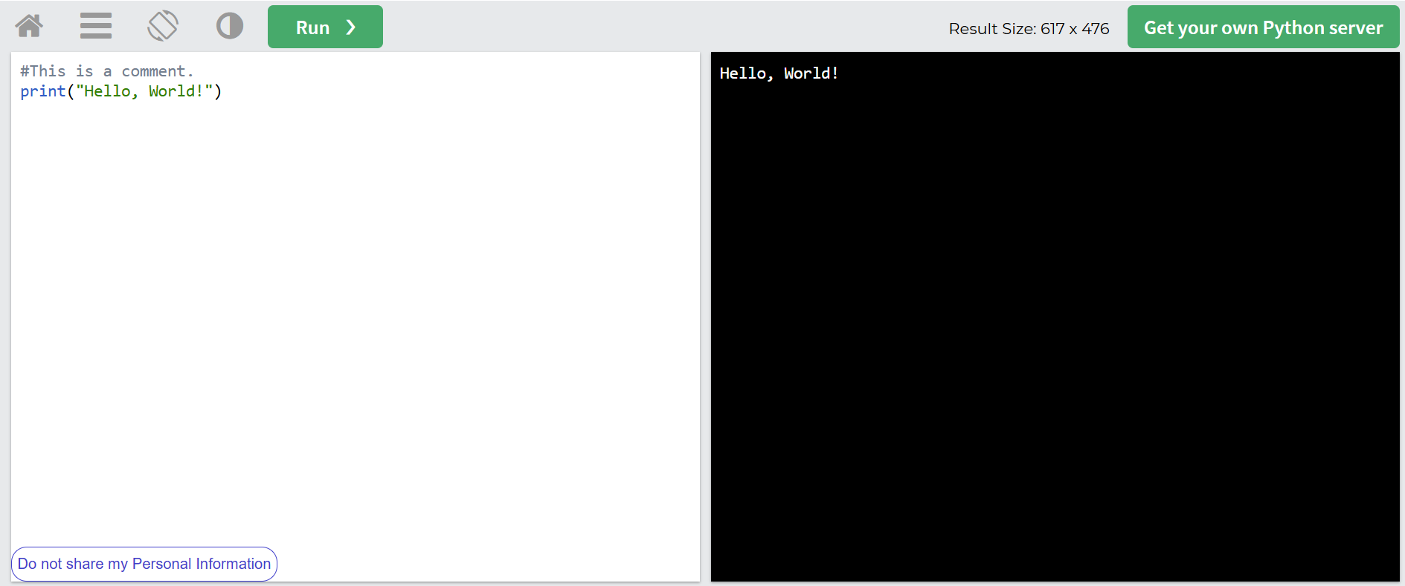
- Python Variables
Assigning Multiple Values to Multiple Variables
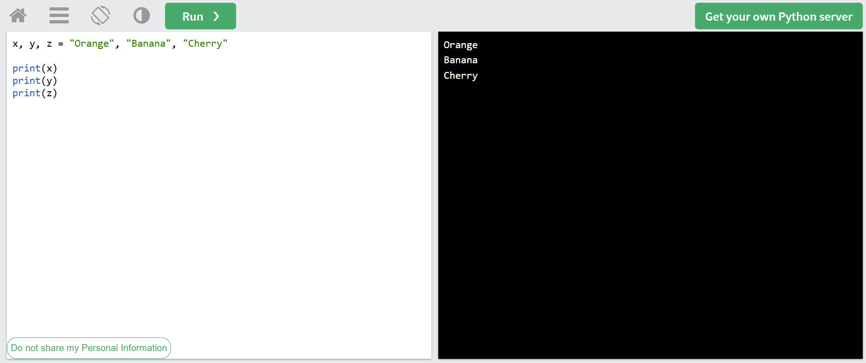
- Python Data Types
Printing the type of a variable
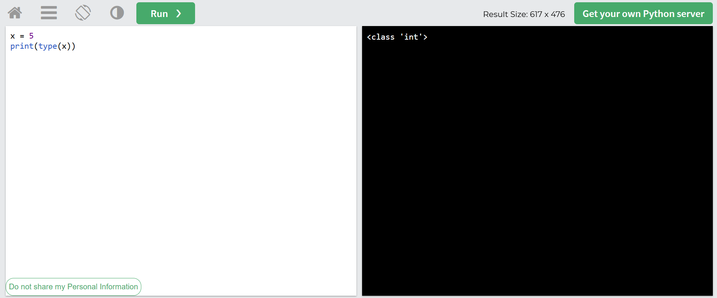
- Python Numbers
Scientific notation
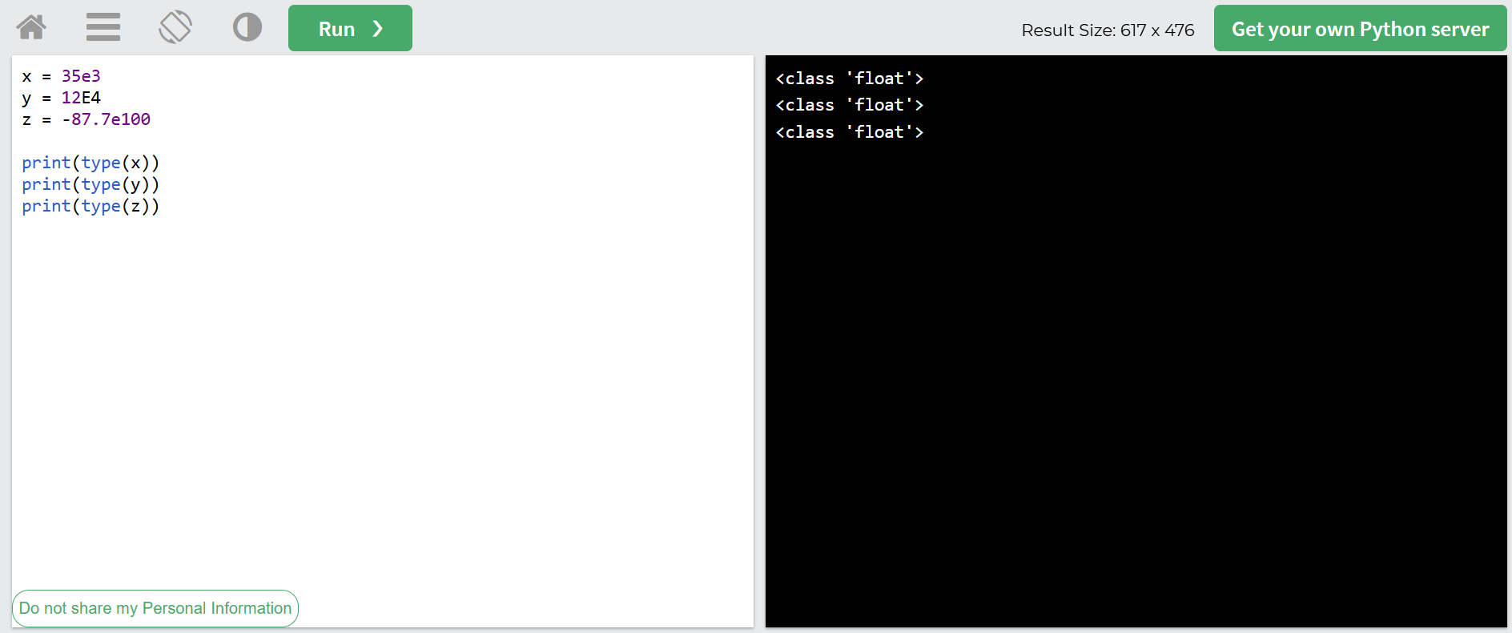
- Python Casting
Changing type of variable
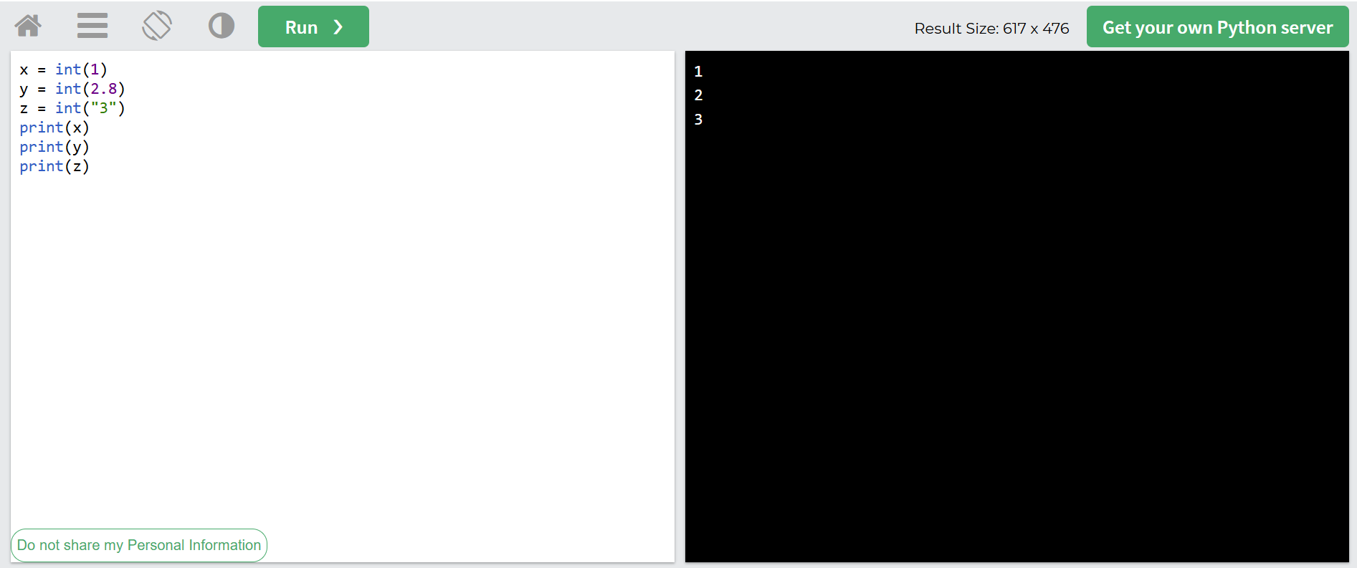
- Python Strings
Escape character
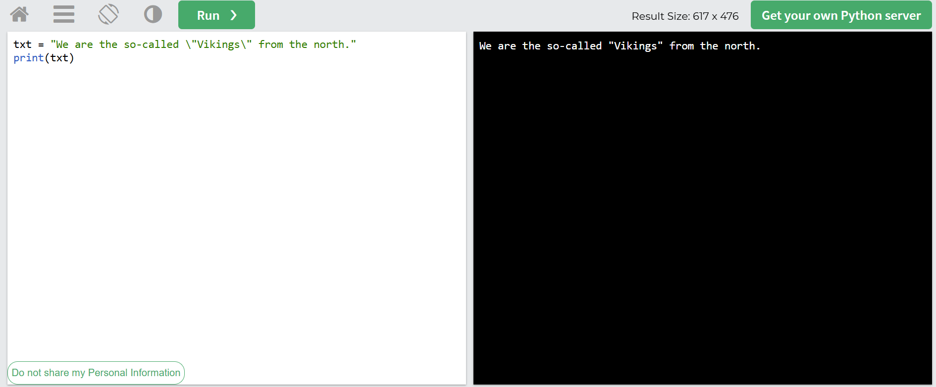
- Python Booleans
True or False Values
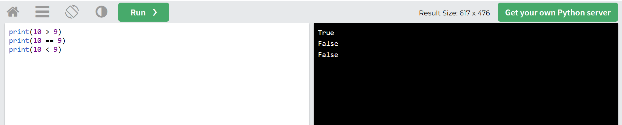
- Python Operators
Adding two values
- Python Lists
Sort Strings alphabetically
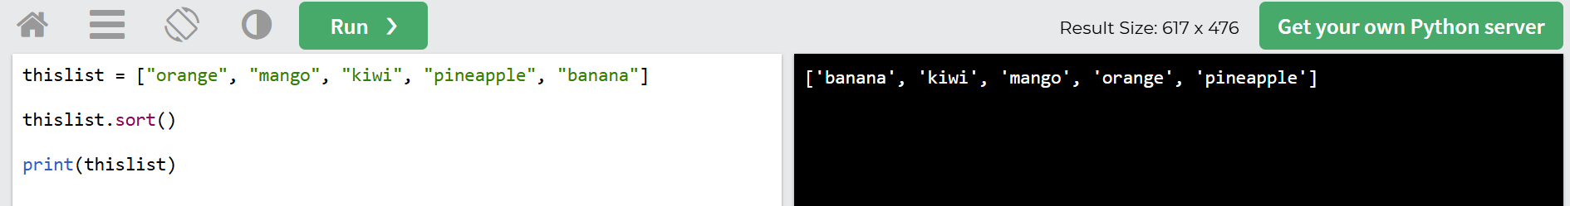
- Python Tuples
Creating a Tuple
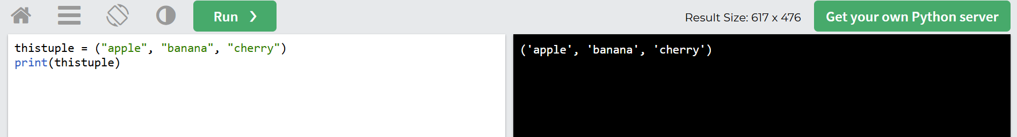
- Python If...Else
Condition in Python
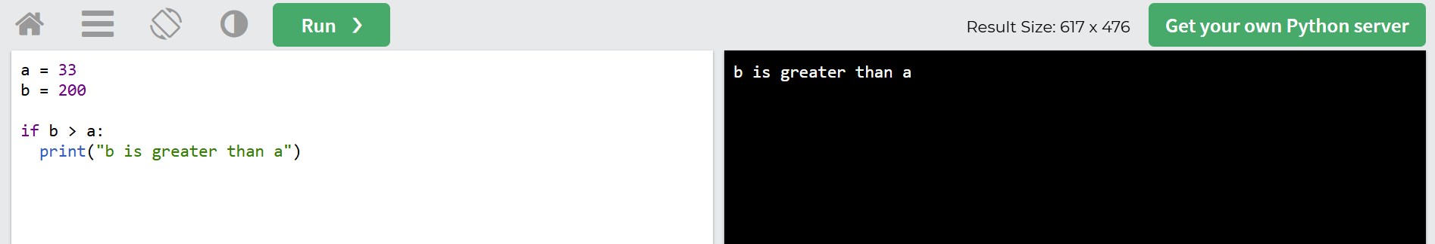
- Python While Loops
While loops in Python
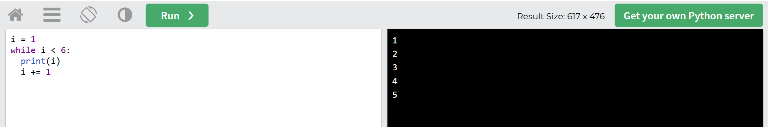
- Python For Loops
For loops in Python
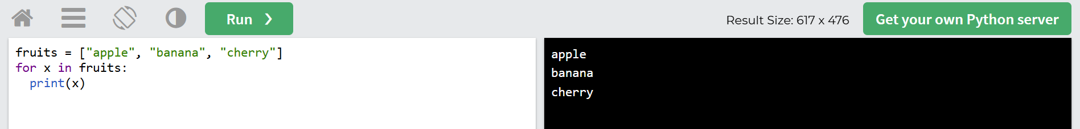
- Python Functions
Calling a function
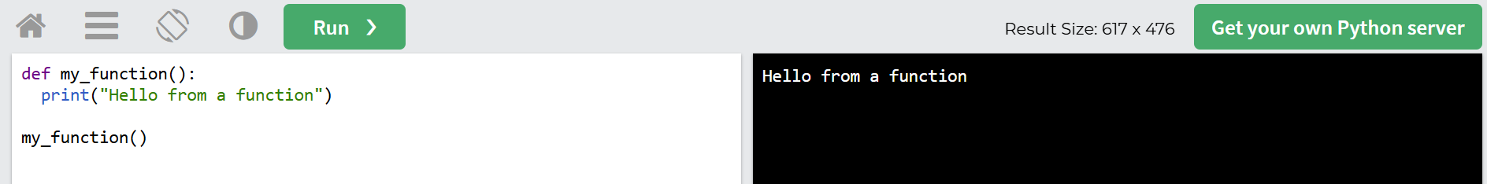

File Handling
- Python File Handling
Open File
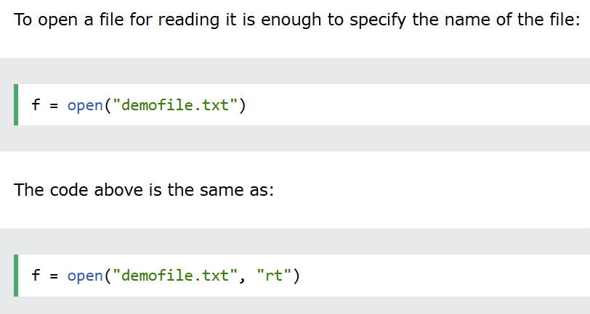
- Python Read Files
Reading Files
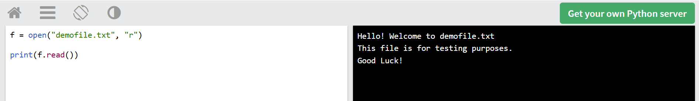
- Python Write/Create Files
Writing to file
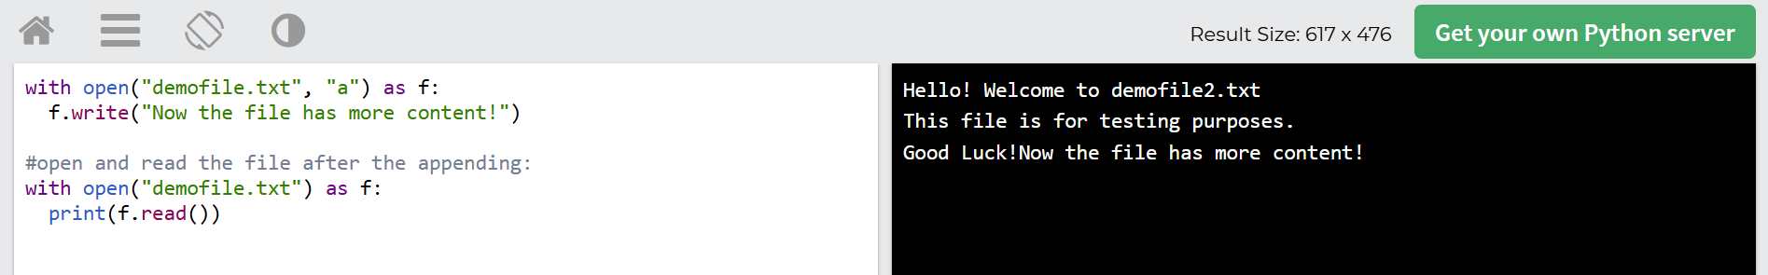

Part 2. In a minimum of 3 sentences, describe your experience with the assignment. Indicate which resources you used.

Since I have taken Python previously, these tutorials serves more as a review then a beginner tutorial. I did, however, learn some additional syntax that I was not aware previously. For example, the bitwise operators will manipulate the bits that represents the value.

Part 3 OPTIONAL ACTIVITY
Consider completing the Exercise quizzes at the bottom of each tutorial. No need for screenshots.

